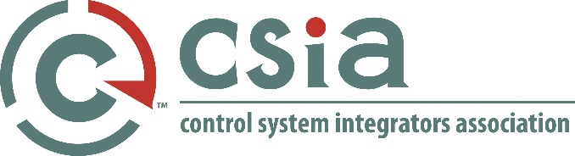
Agenda - DRAFT
CSIA Best Practices Training - Asheville NC
April 29-30, 2019
8:00 am – 4:30 pm
Presenters: Tom Sulda, Barry Anderson
Location: Taft (breakfast & lunch will be in Roosevelt)
In case of emergencies – please contact Jose Rivera (847) 345-5128 or Jill Gabbert (630)921-1321
April 29, 2019
7:30 – 8:00 am | Shared Breakfast (Roosevelt)
8:00 – 8:15 am | Introductions  - CEO Welcome – Jose Rivera  - Tom & Barry IPX Check  - Participants -around the room  - Course Agenda  - Disclaimers
8:15 – 8:45 am | Chapter 1 Review
8:45 – 9:30 am | Chapter 1 Workshop
9:30 – 10:00 am | Chapter 2 Review
10:00 – 10:45 am | Chapter 2 Workshop & Morning Tea
10:45 – 11:15 am | Chapter 3 Review
11:15 am – 12:00 pm | Chapter 3 Workshop
12:00 – 12:45 pm | Lunch (Roosevelt)
12:45 – 1:15 pm | Chapter 4 Review
1:15 – 2:00 pm | Chapter 4 Workshop
2:00 – 2:30 pm | Benefits of CSIA Certification: Guest TBA
2:30 – 2:45 pm | Afternoon Break
2:45 – 3:15 pm | Chapter 5 Review
3:15 – 4:00 pm | Chapter 5 Workshop
4:00 – 4:30 pm | Wrap Up, Q&A, What to Expect Day 2
April 30, 2019
7:30 – 8:00 am | Shared Breakfast (Roosevelt)
8:00 - 8:30 am | Chapter 6 Review
8:30 – 9:15 am | Chapter 6 Workshop
9:15 – 9:45 am | Chapter 7 Review
9:45 – 10:30 am | Chapter 7 Workshop & Morning Tea
10:30 – 11:00 am | Chapter 8 Review
11:00 – 11:45 am | Chapter 8 Workshop
11:45 am – 12:30 pm | Lunch (Roosevelt)
12:30 – 1:00 pm | Chapter 9 Review
1:00 – 1:45 pm | Chapter 9 Workshop
1:45 – 2:00 pm | Afternoon Break
2:00 – 2:30 pm | Benefits of CSIA Certification: Guest TBA
2:30 – 3:00 pm | Chapter 10 Review
3:00 – 3:45 pm | Chapter 10 Workshop
3:45 – 4:30 pm | Wrap Up, Q&A, Next Steps

